21.67:
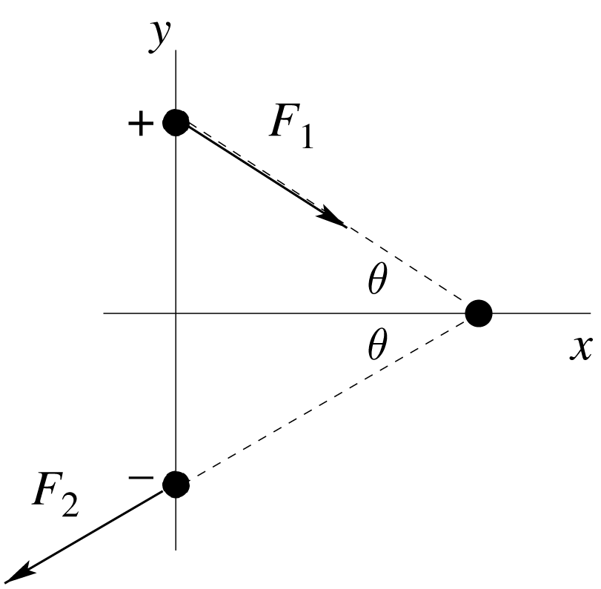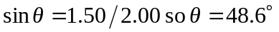
Opposite charges attract and like charges repel.
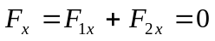
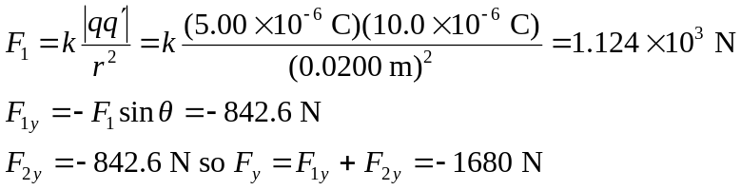
(in the direction from the 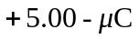charge toward the 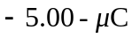charge).
b)
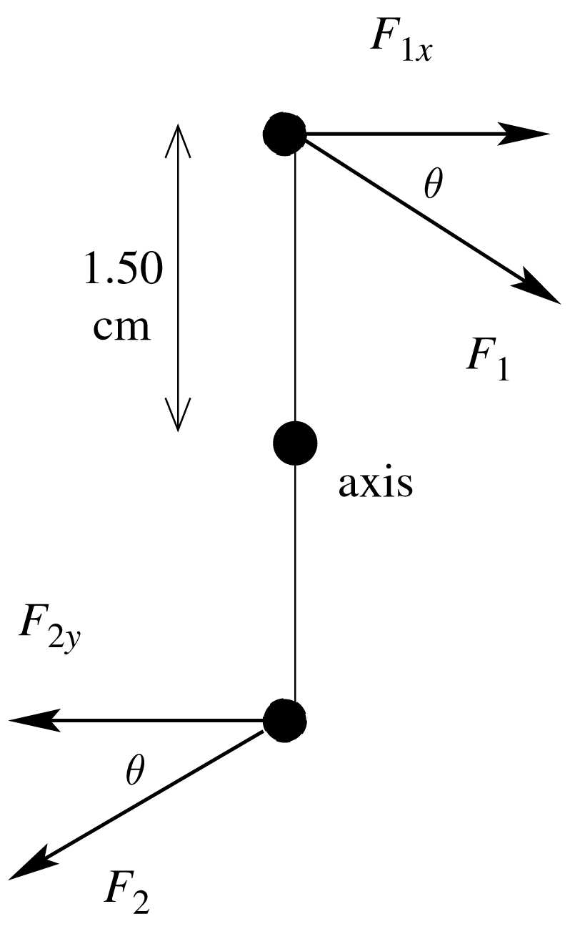The 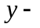components have zero moment arm and therefore zero torque.
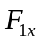and 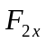both produce clockwise torques.
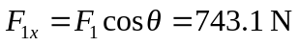
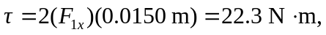 clockwise

